1. **ReactJS HOL**

**Post.js**

class Post {

constructor(userId, id, title, body) {

this.userId = userId;

this.id = id;

this.title = title;

this.body = body;

}

}

export default Post;

**Posts.js**

import React, { Component } from 'react';

import Post from './Post';

class Posts extends Component {

constructor(props) {

super(props);

this.state = {

posts: [],

error: null

};

}

loadPosts = async () => {

try {

const response = await fetch('https://jsonplaceholder.typicode.com/posts');

const data = await response.json();

const postList = data.map(

(p) => new Post(p.userId, p.id, p.title, p.body)

);

this.setState({ posts: postList });

} catch (err) {

this.setState({ error: err });

}

};

componentDidMount() {

this.loadPosts();

}

componentDidCatch(error, info) {

alert("An error occurred in Posts component!");

console.error("Error:", error, info);

}

render() {

const { posts } = this.state;

return (

<div>

<h2>Blog Posts</h2>

{posts.length > 0 ? (

posts.map((post) => (

<div key={post.id} style={{ marginBottom: '30px' }}>

<h3>{post.title}</h3>

<p>{post.body}</p>

<hr />

</div>

))

) : (

<p>Loading posts...</p>

)}

</div>

);

}

}

export default Posts;

**App.js**

import React from 'react';

import Posts from './Posts';

function App() {

return (

<div className="App">

<Posts />

</div>

);

}

export default App;

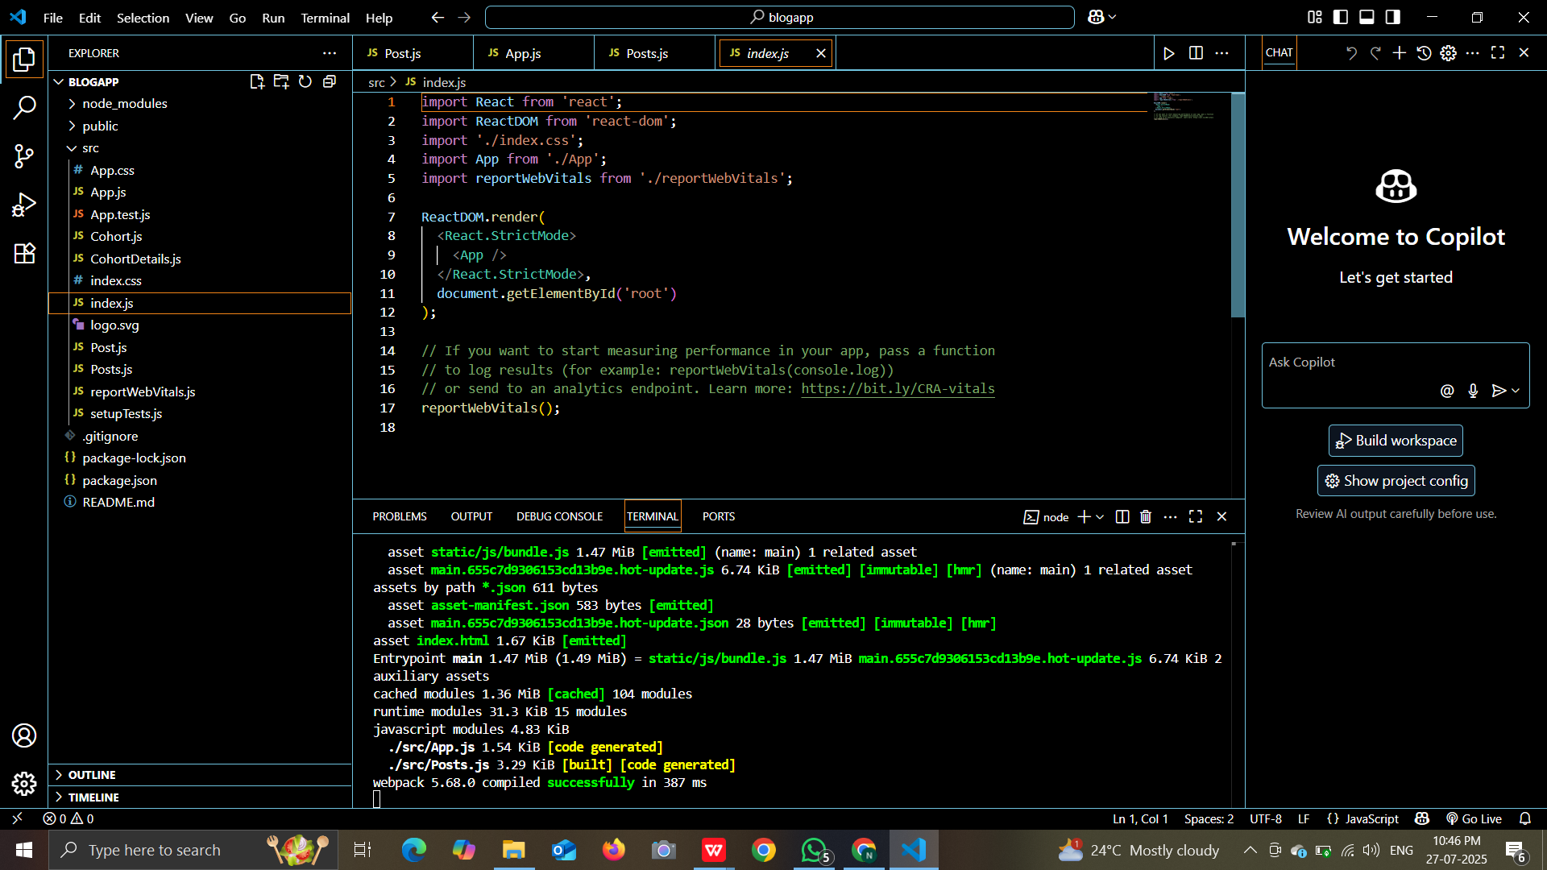

**OUTPUT:**

